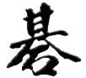
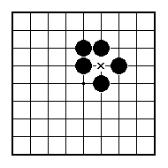
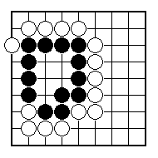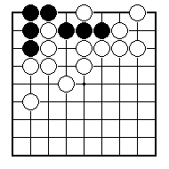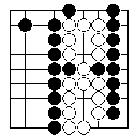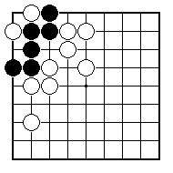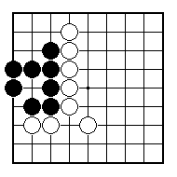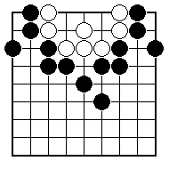
White to play and kill the black group.

Black to play and make the black group live.

White to play and make the white group live.

White to play and kill the black group.

White to play and kill the black group.

Black to play and kill the white group.

NAME:
BRITISH GO ASSOCIATION CERTIFICATE LEVEL 2 - SHEET 10

LIVING AND DEAD GROUPS (PART 1)

